ASSIGNMENT-4
Task 1: Zero-Shot Prompting (Palindrome Number Program)
Prompt: write a python function to check given number is palindrome or not return output int True or False. Provide code in user input.
Code with output:

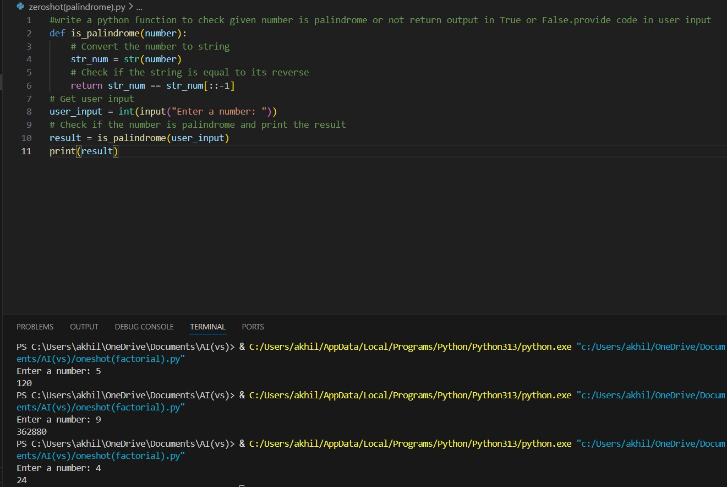
Justification:

- Correct for positive numbers

- Negative numbers not handled clearly

- No input validation for non-integers

Task 2: One-Shot Prompting (Factorial Calculation)
Prompt: write a python function to calculate factorial of given number. Example: input=5 ; output=120
Code with output:

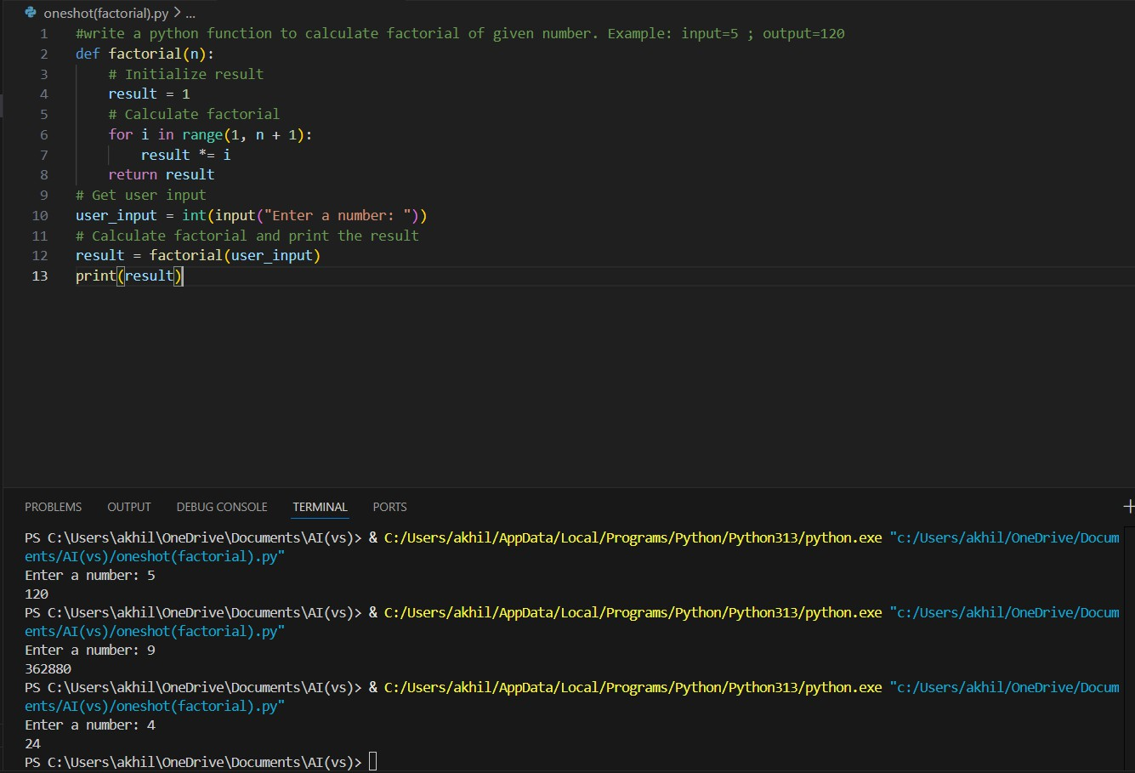
Justification:

- One-shot gives clearer logic

- More readable and reliable

Task 3: Few-Shot Prompting (Armstrong Number Check) Code with output:

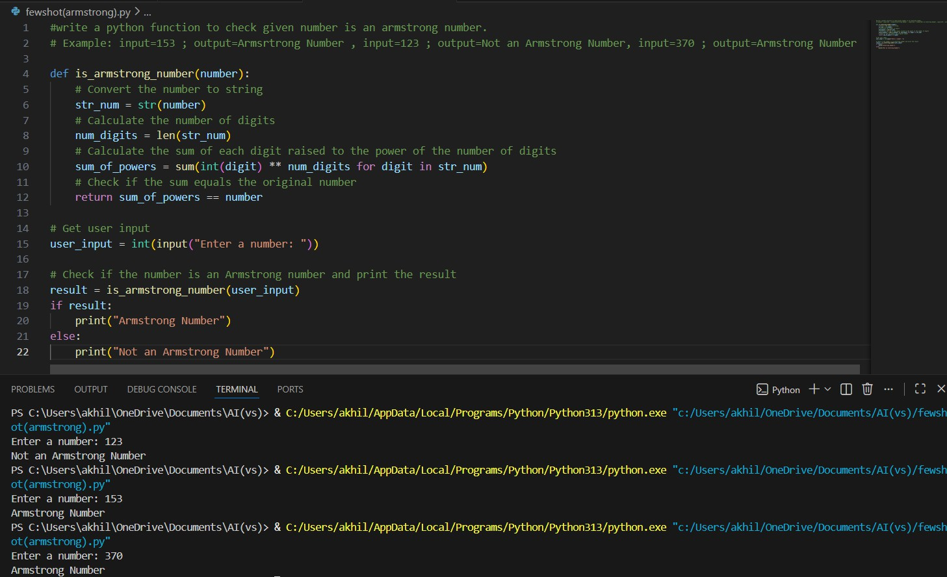
Justification:

- Few-shot improves accuracy

- Code structure matches examples

- Still lacks input validation for negatives

Task 4: Context-Managed Prompting (Optimized Number Classification)
Prompt: generate an optimized python program that classifies a number is prime, composite or neither
Code with output:

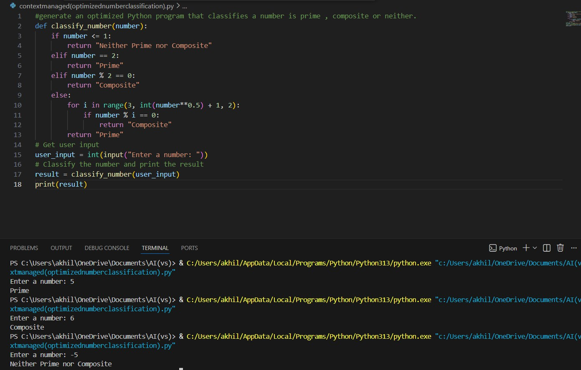
Justification:

- Best performance among all prompts

- Clear validation and optimized logic

- Context improves efficiency and correctness

Task 5: Zero-Shot Prompting (Perfect Number Check)
Prompt:generate a python function to check given number is a perfect number.
Code with output:

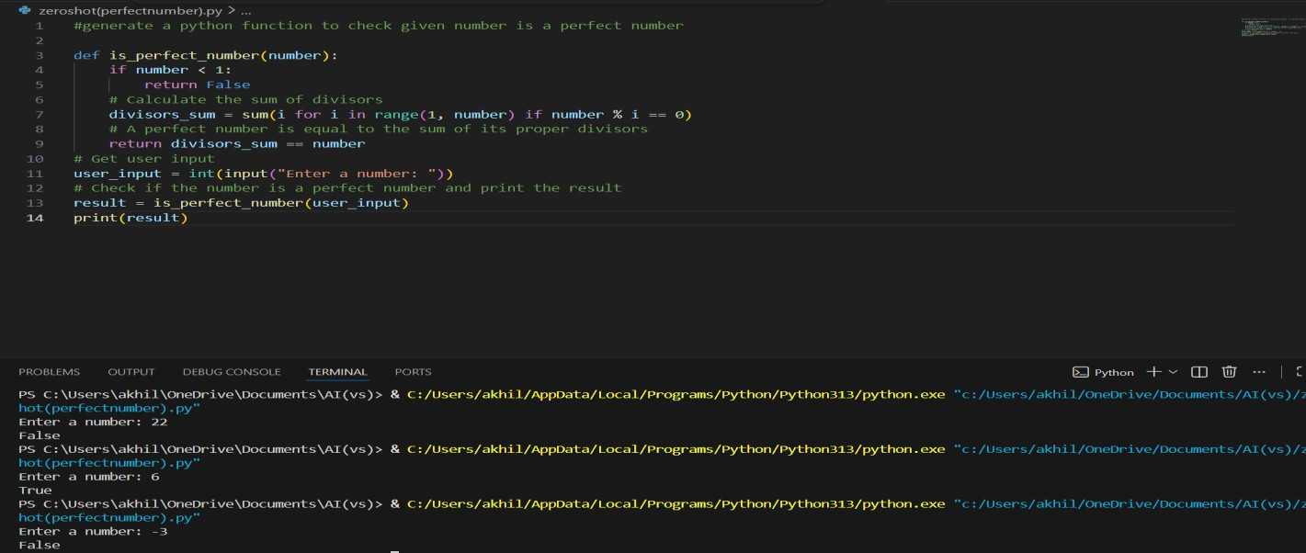

Task 6: Few-Shot Prompting (Even or Odd Classification with Validation)
Code with output:
